HAND GESTURE CONTROLLED VIRTUAL MOUSE USING ARTIFICAL INTELLIGENCE

A

Mini Project Report submitted to Savitribai Phule Pune University, Pune



In partial Fulfillment for the awards of Degree of Engineering in ARTIFICIAL INTELLIGENCE AND DATA SCIENCE ENGINEERING

**Submitted by**

**Mr. Galhe Prathmesh Dattatray Exam Seat No.**

**Mr. Thorve Avishkar Shrikrushna Exam Seat No.**

**Mr. Lohote Sahil Shankar Exam Seat No.**

**Under the Guidance of**

**Mrs. Prof. S. K. Said**

**Designation of Guide**



**May 2023-24**

**Department of Artificial Intelligence and data science Engineering**

Jaihind College of Engineering, Kuran Dist.Pune

Jaihind College of Engineering, Kuran, Dist. Pune

**Department of Artificial Intelligence and data science Engineering**

(2023-24)

**Certificate**



This is to certify that,

Mr.Galhe Prathmesh Dattatray Exam Seat No.

Mr.Thorve Avishkar Shrikrushna Exam Seat No.

Mr.Lohote Sahil Shankar Exam Seat No.

Have successfully completed the Mini project entitled **“HAND GESTURE CONTROLLED VIRTUAL MOUSE USING ARTIFICAL INTELLIGENCE**”under my guidance in partial fulfillment of the requirements for the Second Year of Engineering in ARTIFICIAL INTELLIGENCE AND DATA SCIENCE ENGINEERING under the Savitribai Phule Pune University during the academic year 2023-2024

**Date : 19/04/2024**

**Place: Kuran**

**……………………………….**

**Mrs. Prof. S. K. Said**

**Project Guide**

**Mrs. Prof. S. K. Said**

**Head,**

**DEPARTMENT OF ARTIFICIAL INTELLIGENCE AND DATA SCIENCE ENGINEERING.**

**Acknowledgements**

With deep sense of gratitude we would like to thank all the people who have lit our path with their kind guidance. We are very grateful to these intellectuals who did their best to help during our project work.

It is our proud privilege to express a deep sense of gratitude to **Dr. D. J. Garkal Principal** of Jaihind College of Engineering, Kuran, for his comments and kind permission to complete this project. We remain indebted to **Dr. S. K. Said,** H.O.D.ARTIFICIAL INTELLIGENCE AND DATA SCIENCE ENGINEERING Department for his timely suggestion and valuable guidance.

The special gratitude goes to Said excellent and precious guidance in completion of this work .We thanks to all the colleagues for their appreciable help for our working project. With various industry owners or lab technicians to help, it has been our endeavor throughout our work to cover the entire project work.

We are also thankful to our parents who provided their wishful support for our project completion successfully .And lastly we thank our all friends and the people who are directly or indirectly related to our project work.

Mr. Galhe Prathmesh Dattatray

Mr. Thorve Avishkar Shrikrushna

Mr. Lohote Sahil Shankar

**Abstract**

The use of hand gesture recognition in controlling virtual devices has become popular due to the advancement of artificial intelligence technology. A hand gesture-controlled virtual mouse system that utilizes AI algorithms to recognize hand gestures and translate them into mouse movements is proposed in this paper. The system is designed to provide an alternative interface for people who have difficulty using a traditional mouse or keyboard. The proposed system uses a camera to capture images of the user’s hand, which are processed by an AI algorithm to recognize the gestures being made. The system is trained using a dataset of hand gestures to recognize different gestures. Once the gesture is recognized, it is translated into a corresponding mouse movement, which is then executed on the virtual screen. The system is designed to be scalable and adaptable to different types of environments and devices. All the input operations can be virtually controlled by using dynamic/static hand gestures along with a voice assistant. In our work we make use of ML and Computer Vision algorithms to recognize hand gestures and voice commands, which works without any additional hardware requirements. The model is implemented using CNN and media pipe framework. This system has potential applications like enabling hand-free operation of devices in hazardous environments and providing an alternative interface for hardware mouse. Overall, the hand gesture-controlled virtual mouse system offers a promising approach to enhance user experience and improve accessibility through human-computer interaction.

**Keyword**: Computer vision, hand gesture recognition, Media-pipe, virtual mouse.

**Table of Contents**

**Abstract**

**Table of Contents i**

**List of Abbreviations ii**

**List of Figures iii**

**List of Tables**

**1.** **Introduction**

1.1 Overview

1.2 Aim/Motivation

1.3 Objective

1.4 Organization of Report

**2.** **Literature Survey**

**3. Problem Statement**

**4. Software Requirements Specification**

4.1 Hardware Requirements

4.2 Software Requirements

**5. System Design**

5.1 Project Block Diagram

5.2 GUI of Working System

**6. Conclusion and Future Scope**

**References**

**List of Abbreviations**

1. MHI Motion History Image
2. HCL Human Computer Interaction
3. LED Light Emitting Diodes
4. OPEN CV Open Source Computer Vision
5. RGB Red, Green, Blue
6. HSV Hue, saturation and Values
7. GUI Graphical User Interface
8. IDE Integrated Development Environment
9. CNN Convolutional Neural Networks
10. SVM Support Vector Machines
11. HMM Hidden Markov Models

**List of Figures**

Figure 1 Block Diagram 27

Figure 2 For the Mouse Cursor Moving around the Computer Window 18

Figure 3 To Perform Left Button Click operation 18

Figure 4 To Perform Right Button Click operation 19

Figure 5 To perform a double click operation. 19

Figure 6 To perform scrolling operation 20

Figure 7 To perform drag and drop operation. 21

Figure 8 To perform volume controlling 22

Figure 9 To perform brightness controlling 22

Figure 10 For No Action / neutral gesture to be Performed on the Screen. 23

Figure 11 To launch and end the gesture recognition 24

Figure 12 To search for something over internet 25

Figure 13 To find a location what we are looking for 25

Figure 14 To get an idea about Date and time 26

Figure 15 To exit voice assistant 27

**Chapter 1**

**Introduction**

* 1. **Overview**

Hand gesture-controlled virtual mouse using artificial intelligence (AI) is a cutting-edge technology that enables users to interact with computers or digital devices without physical touch, solely through hand gestures. This innovative system combines computer vision, machine learning, and gesture recognition techniques to interpret and respond to hand movements accurately

* 1. **Aim/Motivation**

1. **Enhanced User Experience.**
2. **Accessibility and Inclusivity.**
3. **Efficiency and Productivity.**
4. **Seamless Integration with Emerging Technologies.**
5. **Adaptability and Personalization.**
6. **Robustness and Reliability.**
   1. **Objective**

To develop and implement a system through which people can communicate with the computer system solely using various hand gestures is our objective. It provides an alternative to physical PC mouse and allows an individual to perform various mouse functions. Also, we can include more features in this application to get better functionalities from the system which makes it scalable and more efficient than physical mouse.

* 1. **Organization of Report**

The world is full of technology driven factors in our day to day life. We have so many technologies, throughout the world computer technologies are growing simultaneously. They are used to perform various tasks which cannot be performed by humans. In fact they are ruling the human lives because they have a potential to do the tasks which cannot be done by humans. The interaction between human and computer can be done with output device like mouse. The mouse is a device used for interacting with a GUI which includes pointing, scrolling and moving etc. The hardware mouse in computers and touchpads in laptops will require a huge amount of time to perform complex tasks, in case we are carrying hardware mouse wherever we go it would be damaged sometimes. After decades the technology has made the mouse functionality from wired into the wireless to improve the functionality and for the easy movements in hassle free manner. As the technologies started growing there came the speech recognition technique. This recognition is mainly used for the voice recognition purpose for searching something with the help of their voice and for translation purposes but it can take time for recognition to perform mouse functions. Later the human computer interaction evolved with the eye tracking techniques for controlling the cursor of the mouse. The major drawback of this technique is that some may wear contact lens or some may have long eyelashes so it may take some time to capture their eye movement. Different types of attempts taken by many developers for developing the models for human gesture recognition. Those models require expensive gloves and sensors for capturing and color cap for marking the positions of the fingertips. The technologies are still emerging; one of the vast technologies artificial intelligence is playing a major role in every sector. Artificial intelligence makes human life fast and comfortable. To overcome the problems faced in the existing approaches we are going for the latest algorithms and tools in artificial intelligence. Hand gesture controlled virtual mouse using artificial intelligence is a technology that allows users to control the movement of their computer mouse using hand gestures, without the advent of a physical mouse. This technology uses a camera vision based approach to track the movements of the user’s hand and to perform mouse functions on the computer screen. The system works by capturing video input from a camera pointed at the user’s hand. The computer vision algorithms then analyze the video feed to identify the user’s hand and track its movement. This information is given to machine learning models which have been trained to recognize specific hand gestures, such as pointing or swiping, and translate them into corresponding mouse movements. This latest super cool technology has various advantages, including its potential to improve accessibility for people and its ability to provide a more natural and intuitive user experience. It can also be useful in situations where a physical mouse or touchpad is not available or practical. The use of hand gestures as a control mechanism eliminates the need for a physical mouse and provides a more intuitive and natural way of interaction with computers. This technology has numerous applications in areas such as gaming, virtual reality and accessibility quite easy for people.

**Chapter 2**

**Literature Survey**

Some work which is related to the AI virtual mouse had been performed previously in that glove were used by the user to recognize and collect data from the system. Later another system used colored pieces of paper which are attached on hands for gesture recognition. But these systems are not very feasible for performing mouse operations accurately. In a glove based approach recognizing the gloves is not viable and it might be allergic for users who have sensitive skin type. Also wearing gloves for a long time is difficult. It might sweat and result in skin rashes and allergic reactions. In the case of colored tips for gesture recognition and detection will not always give best results. Now some others have made contributions that use Google’s work with the media pipe framework. The current gesture controlled virtual mouse uses hand gestures to perform mouse functions, in which we have control over the mouse cursor and perform certain mouse operations like left click, right click, drag and drop, volume control and brightness control etc. Efforts have been made for hand gesture recognition with camera-based detection of the hand gesture interface.

[1] This review is about how a hardware-based system is developed. Although this model produces incredibly accurate results, many movements are challenging to execute while wearing a glove that severely limits the user's hand's range of motion, speed, and agility. Also wearing gloves for a long time will result in skin diseases and is not best suited for the users with sensitive skin type.

[2] They created a machine-user interface that uses straightforward computer vision and multimedia techniques to accomplish hand gesture detection. However, a significant disadvantage is that skin pixel identification and hand segmentation from stored frames must be completed before working with gesture comparison techniques.

[3] They described a system in this study for recognizing hand movements that relies on a mobile phone's camera and a connected mobile projector as a visual feedback medium. Other mobile applications can easily link to their framework to learn gesture recognition. The suggested architecture enables the quick and simple creation of research prototypes that support gestures, diverting the user's focus away from the device and towards the content.

[4] A method for performing mouse functions without any electrical equipment like sensors. It requires a webcam alone. And mouse functions like clicking and dragging files are carried out through hand gestures. The suggested model performance is low with accuracy and lacks more mouse functionality.

[5] This study focuses on the advanced study of robots with gesture controls. The first section gives an idea of the art for hand gesture identification as it relates to how they are seen and captured by common video cameras. Based on estimations of the smoothed optical flow, we extract a collection of motion features. Face detection is used to produce a user-centric representation of this data, and an effective classifier is trained to differentiate.

[6] In this model the hand’s center is determined, and the hand’s calculated radius is discovered. And using the convex hull technique, fingertip points have been determined. The hand gesture is used to control every mouse movement. And the problem of this approach is the frame must first be saved before being processed for detection, which takes longer than what is needed in real-time.

[7] The vision based technique has been tried out in this system. Utilized a webcam for gesture recognition and detection. And no external devices like sensors and gloves were used. Completely focuses on leveraging the YOLOv5 algorithm and Artificial Intelligence (AI) to recognize hand gestures and improve HCI.

[8] The system can create colored masks utilizing techniques for color variation. Later mouse functions are carried out using hand gestures. This approach is difficult in its implementation.

**Chapter 3**

**Problem Statement**

Despite advancements in human-computer interaction, traditional input methods such as mice and touchpads still present limitations in terms of accessibility, intuitiveness, and user experience. Moreover, emerging technologies such as virtual reality (VR), augmented reality (AR), and smart devices demand more natural and immersive interaction paradigms. In this context, there is a need for a hand gesture-controlled virtual mouse system leveraging artificial intelligence (AI) to overcome these challenges and provide users with a seamless and intuitive means of interacting with digital interfaces.

**Key Issues:**

**Limited Accessibility:** Traditional input devices may pose accessibility challenges for individuals with physical disabilities or impairments, hindering their ability to interact with digital interfaces effectively.

**Complexity of Interaction:** The use of traditional input peripherals can be cumbersome, especially in immersive environments such as VR or AR, where users may need to navigate and interact with virtual objects in three-dimensional space.

**User Experience Constraints:** Existing input methods may not fully leverage the capabilities of human hands and gestures, resulting in suboptimal user experiences characterized by inefficiency and lack of naturalness.

**Technical Challenges:** Developing a robust hand gesture recognition system capable of accurately interpreting a wide range of hand movements in real-time presents technical hurdles related to algorithm complexity, computational resources, and environmental robustness.

**Usability and Adoption Barriers:** The adoption of hand gesture-controlled interfaces may be hindered by usability issues such as learning curve, gesture ambiguity, and lack of standardization, impacting user acceptance and adoption rates.

**Security and Privacy Concerns:** Introducing gesture-based interaction raises security and privacy concerns, particularly regarding unauthorized access and unintended actions triggered by unintentional gestures.

**Objectives:**

The primary objective of this research is to design and develop a hand gesture-controlled virtual mouse system using artificial intelligence to address the aforementioned issues and provide users with an intuitive, accessible, and immersive interaction experience. Specific objectives include:

Implementing robust AI algorithms for real-time hand gesture recognition, ensuring high accuracy and reliability across diverse user scenarios and environments.

Designing an intuitive and user-friendly interface that enables seamless interaction with digital interfaces, minimizing learning curves and usability barriers.

Enhancing accessibility by providing customization options and accessibility features tailored to users with diverse needs and abilities.

Optimizing system performance for efficiency and scalability, enabling deployment across various hardware platforms and software environments.

Addressing security and privacy concerns through robust authentication mechanisms, data encryption, and privacy-preserving design principle

**Chapter 4**

**Software Requirements Specification**

**4.1 Hardware Requirements**

The hardware required to run and create the Virtual Mouse program is described below:

• Computer desktop or laptop The machine such as a desktop or laptop will be used to run a visual program that will display what the camera captured. To promote mobility, a notebook, which is a tiny, lightweight, and affordable laptop computer, is offered.

System will be using Processor: Core2Dual

Main Memory: 4GB RAM

Hard Disk: 320GB

Display: 14” Monitor

• Webcam The use of a webcam for image processing allows the application to process images and determine the positions of individual pixels.

**4.2 Software Requirements**

The following describe the software needed in order to develop the Virtual Mouse application • Python Language With the help of the Microsoft Visual Studio integrated development environment (IDE), which is used to create computer programs, the Virtual Mouse application will be coded using the python language. A python library offers many operators, including those for comparisons, logical operations, indirection, bit manipulation, and basic arithmetic.

• Open CV Library Additionally, OpenCV was used in the development of this software. A collection of programming functions for real-time computer vision is called OpenCV (Open Source Computer Version). OpenCV has a tool that can read picture pixel values and can also make eye movement and blink recognition in real time.

Software will be using OS: Window 10 Ultimate 64-bit

Language: Python

Tool Used: Open CV and Media Pipe

**Chapter 5**

**System Design**

**5.1 Project Block Diagram**

There are two main steps in the process of color recognition: the calibration phase and the recognition phase. In the calibration phase, which will be utilized later in the recognition phase, the system will be able to identify the Hue Saturation Values of the colors selected by the users. It will save the parameters and settings into text documents for later use. The system will begin to take frames during the recognition phase and look for color input based on the values that have been stored during the calibration process phase. The following figure depicts the stages of the virtual mouse

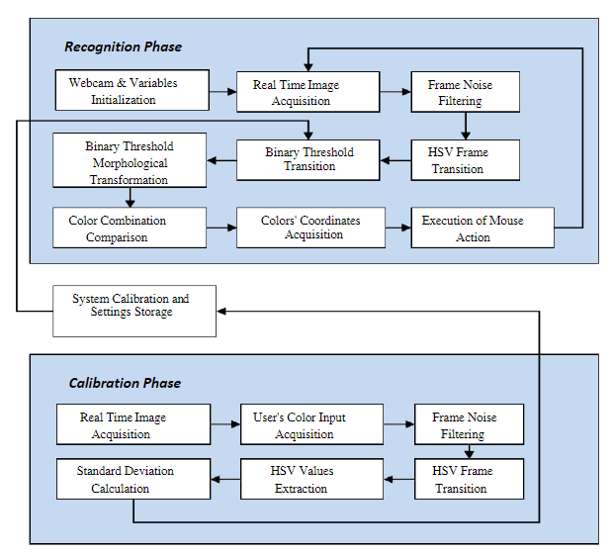

Fig 1: Block Diagram

**5.2 GUI of Working System**

The proposed system uses web camera for capturing images or video based on the frames. For capturing we are using CV library Opencv which is belongs to python web camera will start capturing the video and Opencv will create a object of video capture. To AI based virtual system the frames are passed from the captured web camera.

Mouse Functions Depending on the Hand Gestures and Hand Tip Detection Using Computer Vision:

* For the Mouse Cursor Moving around the Computer Window

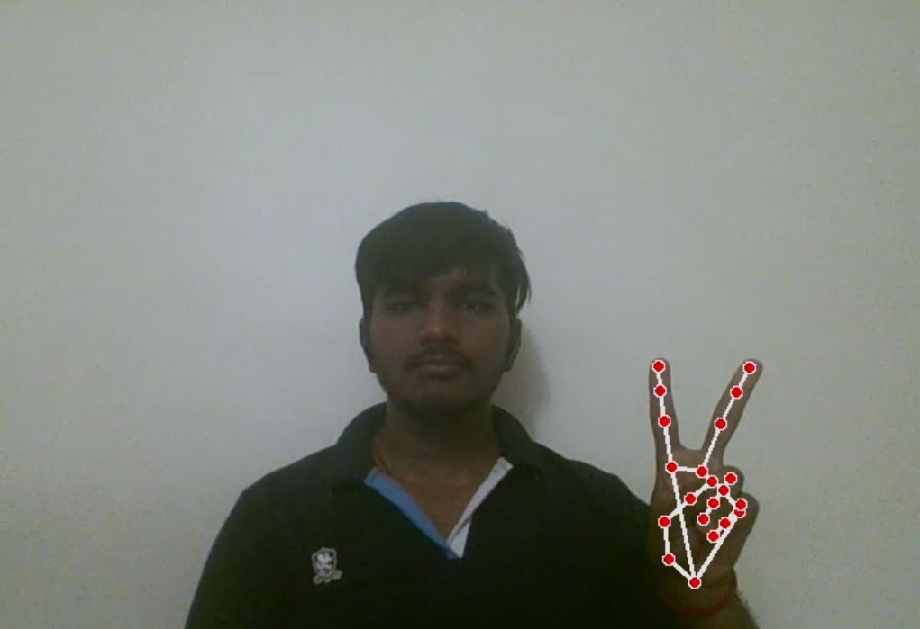

Fig 2: For the Mouse Cursor Moving around the Computer Window

* To Perform Left Button Click operation

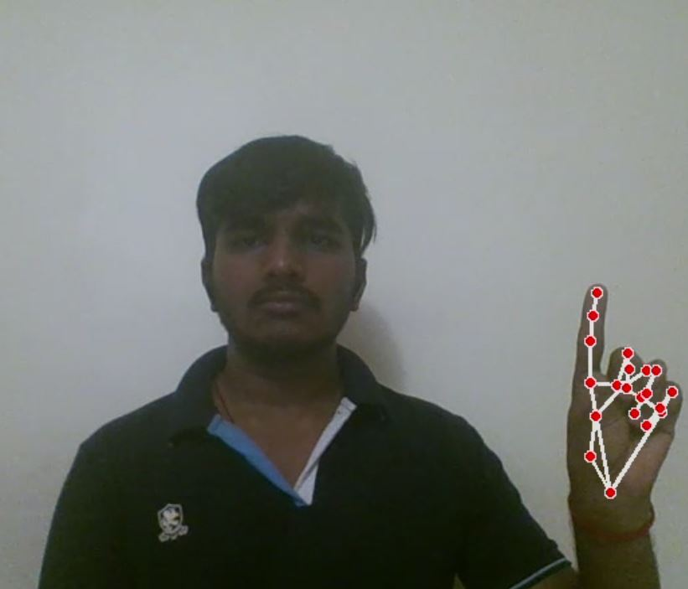

Fig 3: To Perform Left Button Click operation

* To Perform Right Button Click operation.

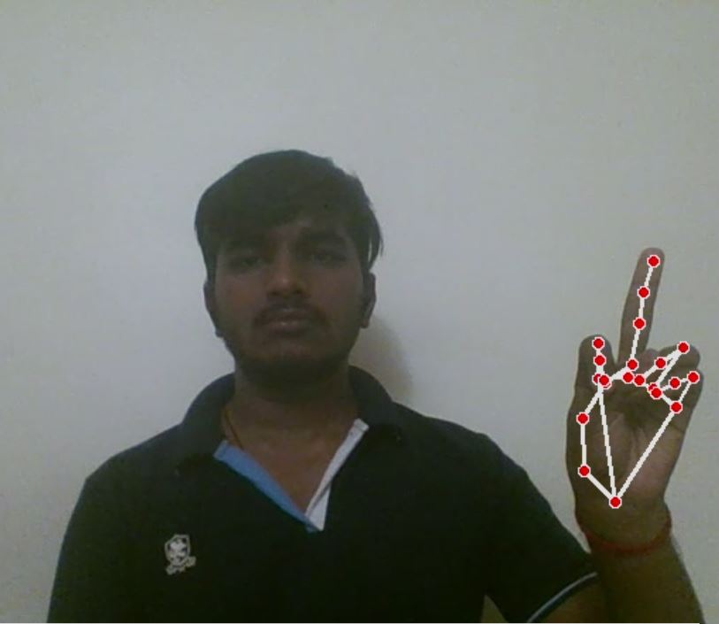

Fig 4: To Perform Right Button Click operation

* To perform a double click operation.

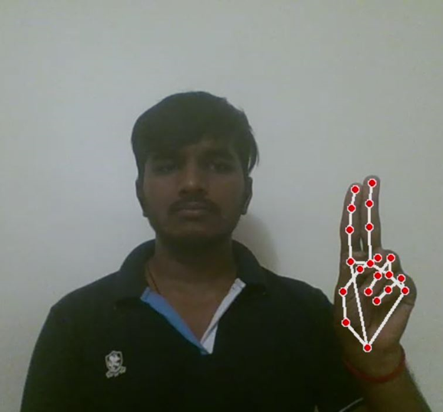

Fig 5: To perform a double click operation.

* To perform scrolling operation.

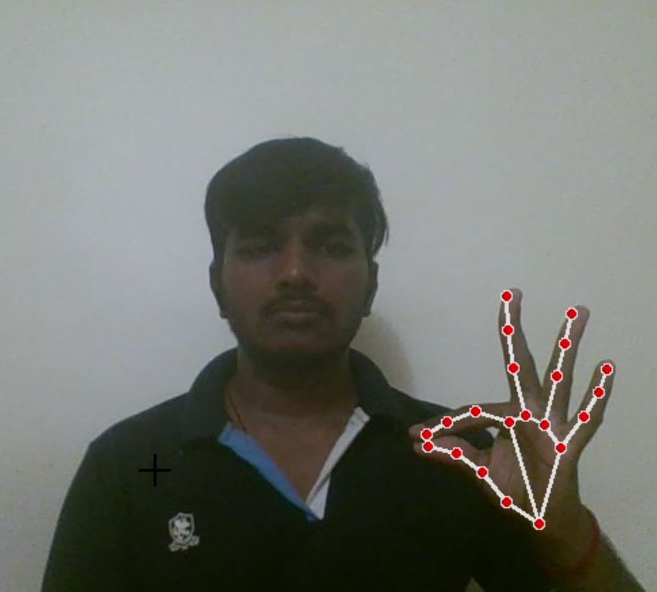

Fig 6: To perform scrolling operation

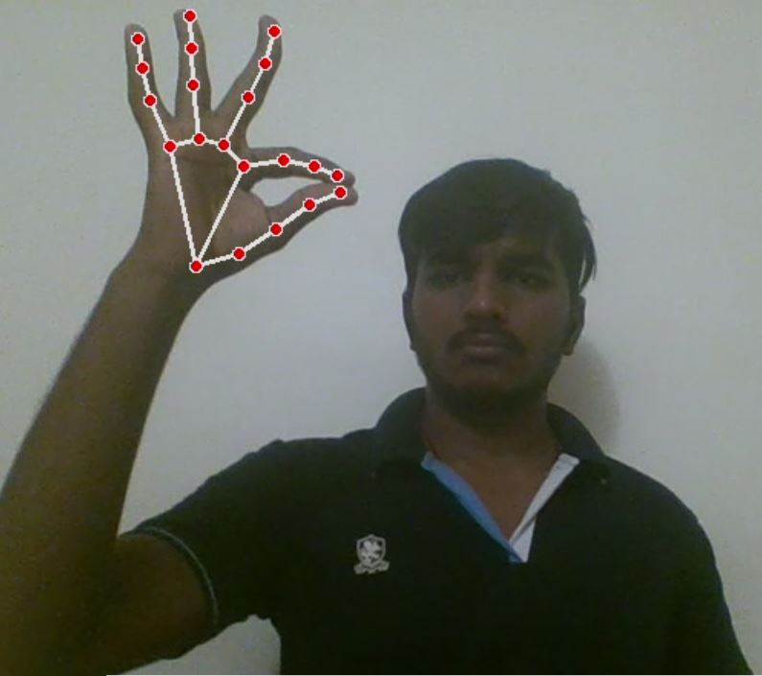

* To perform drag and drop operation.

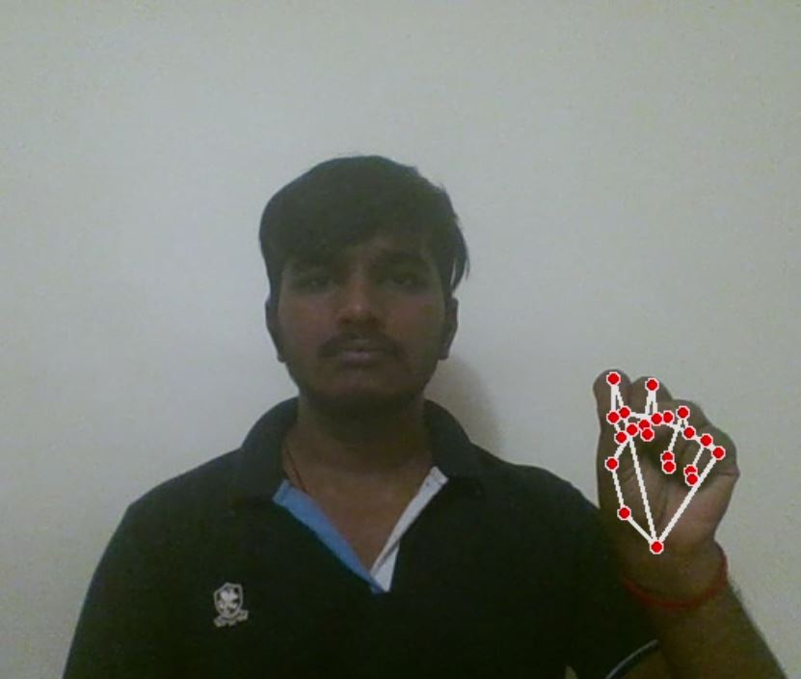

Fig 7: To perform drag and drop operation

* To perform volume controlling.

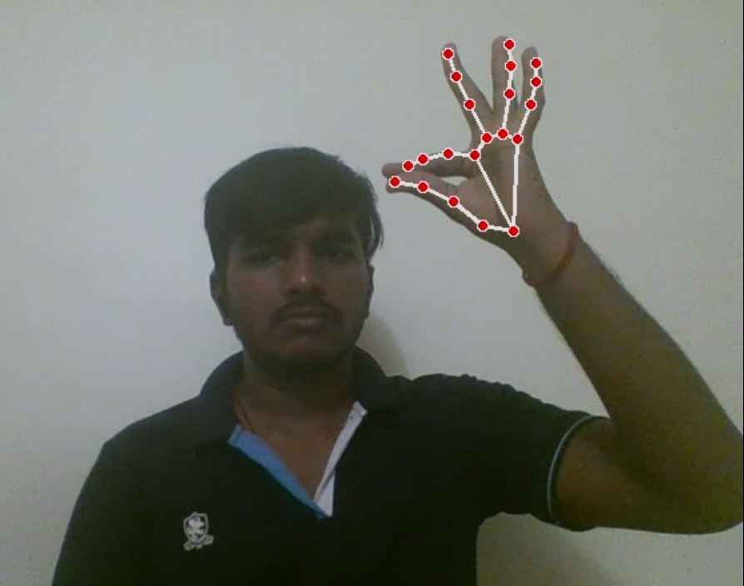

Fig 8: To perform volume controlling.

* To perform brightness controlling.



Fig 9: To perform brightness controlling.

* For No Action / neutral gesture to be Performed on the Screen.

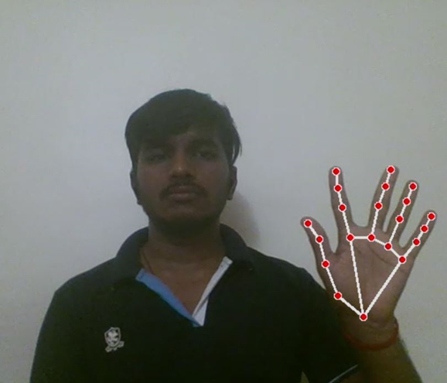

Fig 10: For No Action / neutral gesture to be Performed on the Screen.

* Voice Assistant Features The voice assistant feature has been included to launch gesture recognition through voice commands. And added certain features to improve the user engagement and they can assess whatever they need with less amount of effort and in hassle free manner. The voice assistant features which can be performed through the voice commands are:
* To launch and end the gesture recognition

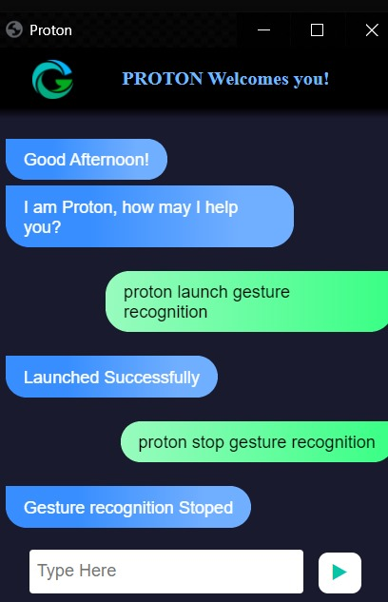

Fig 11: To launch and end the gesture recognition

* To search for something over internet



Fig 12: To search for something over internet

* To find a location what we are looking for

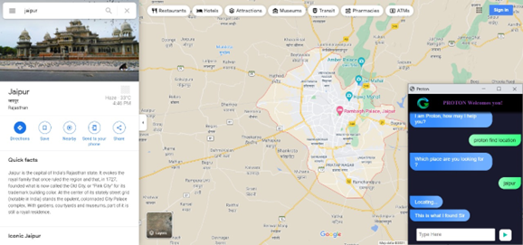

Fig 13: To find a location what we are looking for

* To get an idea about Date and time

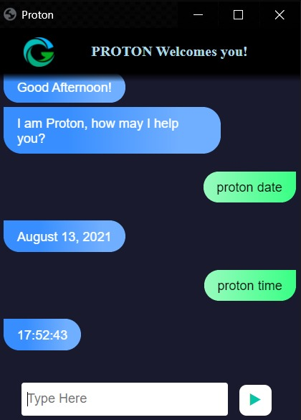

Fig 14: To get an idea about Date and time

* To exit voice assistant

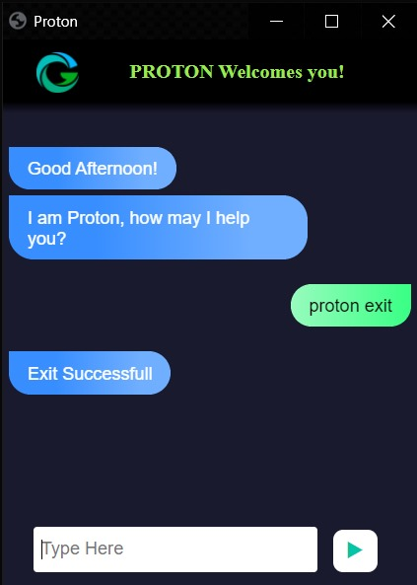

Fig 15: To exit voice assistant

**Chapter 6**

**Conclusion and Future Scope**

AI virtual mouse using hand gestures is an innovative and exciting technology that has the potential to revolutionize the way we interact with computers. Here with the aid of a real-time camera, we have created a system to manage the mouse pointer and carry out its function. It offers users a more natural, intuitive, and accessible way to control the cursor on the screen, without the need for a traditional input device, a mouse. Furthermore, with additional voice assistant support, AI virtual mouse using hand gestures can further enhance the user experience. Voice assistant which is integrated with the virtual mouse system will provide users with even more control over their devices. Users can given voice commands to do a range of tasks, such as opening applications, navigating through menus, and performing web searches, in addition to controlling the cursor on the screen using hand gestures. As technology continues to evolve, we can expect to see even more innovative solutions that enhance the user experience and improve accessibility for all.

**References**

[1]. Quam, D.L., et.al. (1990). Gesture Recognition with a Dataglove. In IEEE conference on Aerospace and Electronics (pp. 755-760).

[2] Guoli Wang., et.al. (2015). Optical Mouse Sensor-Based Laser Spot Tracking for HCI input, Proceedings of the Chinese Intelligent Systems Conference (pp. 329-340).

[3] Baldauf, M., and Frohlich, p. (2013). Supporting Hand Gesture Manipulation of Projected Content with mobile phones. In the European conference on computer vision (pp. 381-390).

[4] Roshnee Matlani., Roshan Dadlani., Sharv Dumbre., Shruti Mishra., & Abha Tewari. (2021). Virtual Mouse Hand Gestures. In the International Conference on Technology Advancements and innovations (pp. 340-345).

[5] Mayur, Yeshi., Pradeep, Kale., Bhushan, Yeshi., & Vinod Sonawane. (2016). Hand Gesture Recognition for Human-Computer Interaction. In the international journal of scientific development and research (pp. 9-13).

[6] Shriram, S., Nagaraj, B., Jaya, J., Sankar, S., & Ajay, P. (2021). Deep Learning Based Real-Time AI Virtual Mouse System Using Computer Vision to Avoid COVID-19 Spread. In the Journal of Healthcare Engineering (pp. 3076-3083).

[7] Steven Raj, N., Veeresh Gobbur, S., Praveen., Rahul Patil., & Veerendra Naik. (2020). Implementing Hand Gesture Mouse Using OpenCV. In the International Research Journal of Engineering and Technology (pp. 4257-4261).

[8] Sneha, U., Monika, B., & Ashwini, M. (2013). Cursor Control System Using Hand Gesture Recognition. In the International Journal of Advanced Research in Computer and Communication Engineering (pp. 2278-1021).

[9] Krishnamoorthi, M., Gowtham, S., Sanjeevi, K., & Revanth Vishnu, R. (2022). Virtual mouse using YOLO. In the international conference on Innovative Computing, Intelligent Communication and Smart Electrical Systems (pp. 1-7).

[10] Varun, K.S., Puneeth, I., & Jacob, T.p. (2019). Virtual Mouse Implementation using OpenCV. In the International Conference on Trends in Electronics and Informatics (pp. 435-438).

[11] Quek, F., et.al. (1994). Towards a vision based hand gesture interface, in Proceedings of Virtual Reality Software and Technology (pp. 17-31).

[12] Tharsanee, R.M., Soundariya, R.s., Kumar, A.S., Karthiga, M., & Sountharrajan, S. (2021). Deep Convolutional neural network-based image classification for COVID-19 diagnosis. In Data Science for COVID-19 (pp. 117-145). Academic Press.

[13] Newell, A., Yang, K., & Deng, J. (2016, October). Stacked hourglass networks for human pose estimation. In the European conference on computer vision (pp. 483-499). Springer, Cham.

[14] Ramakrishna, V., Munoz, D., Hebert, M., Andrew Bagnell, J., & Sheikh, Y. (2014).Pose machines: Articulated pose estimation via inference machines. In the European Conference on Computer Vision (pp. 33-47). Springer, Cham.

[15] Tharani, G., Gopikasri, R., Hemapriya R., & Karthiga, M. (2022). Gym Posture Recognition and Feedback Generation Using Mediapipe and OpenCV. In International Journal of Advance Research and Innovative Ideas in Education (pp. 2053-2057).